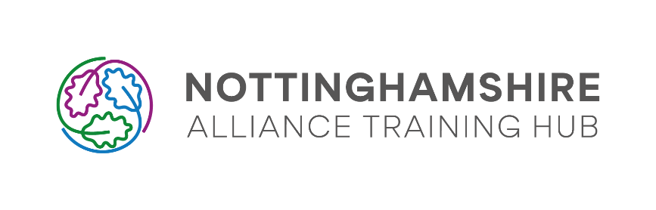
Agreement for advertising events, opportunities, or information
on the Grow Notts Primary Care (GrowNottsPC) Application

The purpose of the below agreement is to enable Nottinghamshire Alliance Training Hub (NATH) to promote events, opportunities and information to primary care staff in Nottingham and Nottinghamshire on behalf of third parties.

This agreement outlines our intentions and expectations for third parties that submit requests to promote events, opportunities and information on the Grow Notts Primary Care App. It also outlines the responsibilities of the contributing organisation and of NATH with respect to the App.

Through the Grow Notts Primary Care Application, NATH intends to:

- Promote high quality educational events to primary care staff in Nottingham and Nottinghamshire
- Link staff to high quality CPD and educational events that are happening in Nottingham and Nottinghamshire from providers such as:
  - Other NHS organisations
  - NHS Hospitals
  - Pharma
  - Private Sector Hospitals
  - Not for profit organisations
  - Other organisations providing relevant training and events
- Link staff to relevant, important and useful information from NHS organisations as well as system partners in community, statutory, education and voluntary sectors.
- Link staff to opportunities for career development, education and other relevant opportunities.

- NATH Expectations

  - Unless an event is being set up in conjunction with NATH (through the CPD team or similar), 3rd parties will submit separate requests for each event, alert and/or page creation/update. This will use our standardised procedure including the use of the Monday.com forms and working to our agreed timescales.

    - The Event Request form can be found here: https://forms.monday.com/forms/4a37bf446a8bafb99f954dd1b85cc855?r=use1
    - The Alert / Page Update form can be found here: https://forms.monday.com/forms/ff0f6fa4f75d843dd217b83f98647d8d?r=use1

  - Any communication arising from App users about specific events/information will be handled by the organiser of the event/author of the information.

    - Where more than one party is responsible for the organisation, a communication lead will be agreed in writing, and communication and information requests will be forwarded to that named individual. We expect that if this person is unavailable, for example due to ill health or leave, a replacement person will be nominated and this will be communicated with NATH.

  - All requests and subsequent events/information conform to our policy below on content, delivery method and intention, unless specifically authorised otherwise by the App Team.

  - All event content, and communication and information around events, will conform to the relevant professional codes of conduct. Individuals involved in events will be expected to follow their own professional codes of conduct. These will include, but not be limited to, the ABPI.

  - 3rd Parties will make it clear in any event/communication that they are separate from NATH. All logos and sponsor names will be accompanied by the phrase ‘Sponsored by’ to ensure transparency.

- Nottinghamshire Alliance Training Hub (NATH) will be responsible for:

  - Processing completed forms.

  - Endeavouring to publish events/info on the app within 10 working days.

- NATH Limitations

  - We do not guarantee that if an event, information message or opportunity is submitted that it will be uploaded to the app, although we endeavour to do this with all appropriate requests.

  - NATH will not be responsible for any communication arising about specific events/information, as above. It is expected that this will be handled by the party delivering the event/communicating the information.

  - We do not guarantee the content of any event, this is the sole responsibility of the providing party including any issues that may arise.

  - If issues or complaints arise in relation to an event or information, or a contributor is found to be in breach of our event or information terms (see below) we reserve the right to remove the event and future events without explanation and without consequence. We will endeavour to feed back to the contributor.

  - NATH is not permitted to show bias towards any company and therefore may involve a sponsor’s competitor on other occasions. NATH cannot therefore enter into any exclusive arrangements regarding sponsorship of education and training opportunities.

  - NATH cannot guarantee that events will only be attended by qualified and registered clinicians, nor that promoted events will only be seen by them. NATH supports student placements within primary and community care settings, and they may therefore be encouraged to take part in supplementary learning opportunities. Providers are expected to clearly mark limitations of attendance within the information on their completed form.

- The Contributing Organisation will be accountable for:

  - Acting in accordance with any industry codes of conduct and company policies.

  - Acting in accordance with the Equalities Act, and avoiding bias, and direct and indirect discrimination against any protected group.

  - Ensuring meetings are education focussed, non-promotional meetings.

  - Ensuring that the vast majority of information or education delivered in an event is general around a product/tool/service using generic names where practical rather than company or brand names.

    - Education providers however are permitted to mention their sponsorship or support of a speaker or event, or a brief mention of a specific product. However, organisers must ensure that this is not the main focus of an event.

  - Providing evidence of insurances relevant to the event if necessary such as but not limited to public liability insurance.

  - Complying with Data Protection and Confidentiality legislation and ensuring any follow-up correspondence with participants offers an opt-out option.

  - The Sponsor may choose to terminate the relationship with NATH and will endeavour to provide constructive feedback.

Please sign below to acknowledge and approve to the above agreement

NATH Representative

Print name:
Signature:
Date:

Contributor/Sponsor Representative

Print name:
Organisation:
Signature:
Date:

