Blackboard Open Education is a virtual learning environment where you will be able to access online course materials and interact with other learners. You will need to create a free account before you can enrol onto the course.

**To create a new account**

1. Visit <https://openeducation.blackboard.com/sheffield> and select the **Login** button which is at the top-right of the screen.
2. Click on the **Don’t have an account? Create one now**. Link.

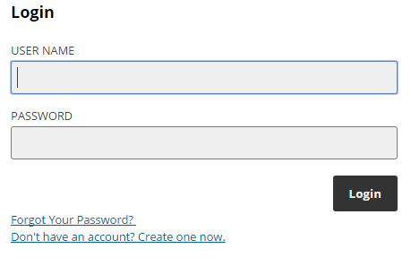

1. Complete the simple registration form. Your **username** and **password** can be anything that you want.
2. Once you have completed the registration form and accepted the terms and conditions, click **Create Account**. You should now have a Blackboard Open account.
3. Email Emily Henderson on hss-placements@sheffield.ac.uk and let them know your username, so you can be enrolled onto the course.

**Enrolling on the course**

Once you have created an account, you will be notified when you have been enrolled onto the course.

The next time you login select the **Login** button in the top right hand corner.

1. Enter your username and password and click the **Login** button.   
   
2. From the homepage the "Speech and Language Therapy: Training for Practice Educators" course should now be listed.

1. Click on **Go to Course** to access the course area.

**What if you forget your password?**

1. If you forget your password, you can change your password by clicking on the **Login** button in the top right hand corner of the screen.
2. From the Login box, choose **Forgot Your Password?**
3. Provide the information required and submit the form.