Improving Clinical Practice to
Achieve the Three Treatment Targets

Half Day training for GPs and Practice Nurses from Nottinghamshire Consultants and DSNs

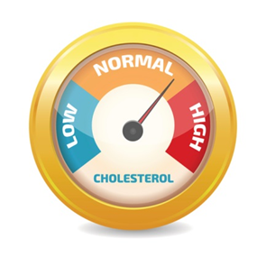
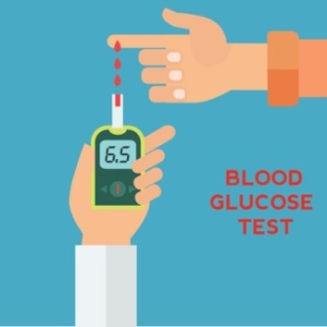
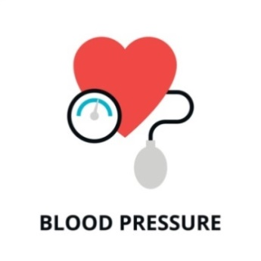

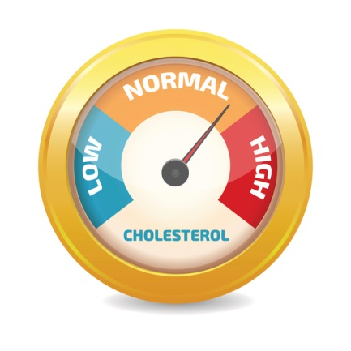

Nottingham & Nottinghamshire CCG are inviting GPs and Practice Nurses to attend one of these half day training workshop.

The topics for this half day module are:

- Blood Pressure
- Lipids and Cardio-Vascular Risk Assessment
- Glycaemic Control

What does the training provide?
Blood Pressure
- Best practice in BP management
- HPBPM vs ABPM
- Review current evidence, guidelines and top tips

Lipids and Cardio-Vascular Risk Assessment
- Assessing risk
- Lipid profile, Statin treatment, Follow-up, Clinical review, Evidence

Glycaemic Control
- Latest NICE (2017) guidance
- Individualising Care
- Targets
- Awareness of Treatment Options

All events from 12.30-4.30pm (inc lunch)

3rd November

Forever Green, Mansfield, NG21 0HJ

11th November

Trent Vineyard, Lenton, NG7 2PX

25th November

Double Tree Hilton, NG8 6AZ

To book a place onto the course please complete the registration form and email it to:

nottinghamdiabetes@gmail.com

© Leicester Diabetes Centre at University Hospitals of Leicester NHS Trust, 2021. Not to be reproduced in whole or in part without the permission of the copyright owner.

These events are being sponsored by AstraZeneca who have had no input into the agenda.

Please reserve a place for me on the Nottinghamshire EDEN 3TT training
PLEASE INDICATE THE DATE & VENUE OF THE MEETING YOU WANT TO ATTEND:

3rd November Forever Green, Mansfield, NG21 0HJ
or
11th November Trent Vineyard, Lenton, NG7 2PX
or
25th November Double Tree Hilton, NG8 6AZ

Name
Job role
Work Address
Email address
Mobile/contact number
Any special dietary requirements
REGISTRATION FORM – PLEASE EMAIL TO:
nottinghamdiabetes@gmail.com

You will receive an confirmation email that a place has been reserved for you.

