Flu Vaccination Toolkit
Flu vaccination is especially important this year because:
- more people are likely to get flu this winter as fewer people will have built up natural immunity to it during the COVID-19 pandemic
- if you get flu and COVID-19 at the same time, research shows you're more likely to be seriously ill
- getting vaccinated against flu will provide protection for you and those around you
If you've had COVID-19, it's safe to have the flu vaccine. It will still be effective at helping to prevent flu.
Due to COVID-19 it is more important than ever before that vulnerable groups receive the flu vaccine to make sure they are protected and reduce winter pressures on the NHS.
- It is still safe to get vaccinated despite COVID-19. Safety measures are in place and surgeries will be keeping social distancing in place throughout flu season so it is safe for patients to come in and be vaccinated.
People eligible for the vaccine include those who:
- are 50 and over (including those who'll be 50 by 31 March 2022)
- have certain health conditions
- are pregnant
- are in long-stay residential care
- receive a carer's allowance, or are the main carer for an older or disabled person who may be at risk if you get sick
- live with someone who is more likely to get infections (such as someone who has HIV, has had a transplant or is having certain treatments for cancer, lupus or rheumatoid arthritis)
- frontline health or social care workers
Where to get the flu vaccine
You can have the NHS flu vaccine at:
- your GP surgery
- a pharmacy offering the service – find one here: Find a pharmacy that offers the NHS flu vaccine - NHS (www.nhs.uk)
- your midwifery service if you're pregnant
- a hospital appointment
Social Media
Here is some suggested social media copy and content for you to use to help promote the flu vaccination to your followers.
Topic | Content | Image
Flu general | This winter it’s essential you protect yourself and others against flu.  Many adults, most children and all pregnant women are eligible for a free flu vaccine.  Book your appointment now.  www.nhs.uk/wintervaccinations | 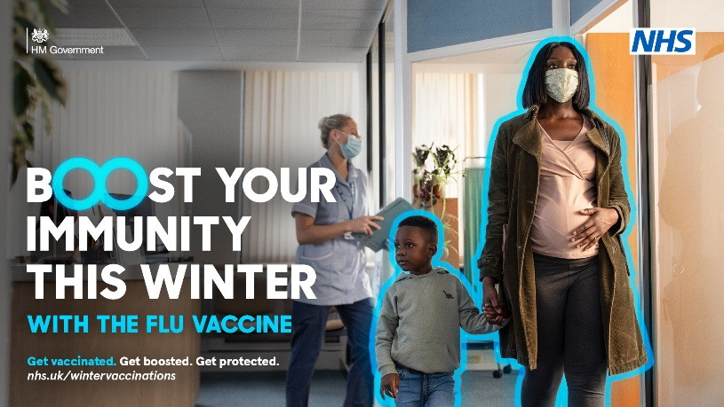
Flu general | This winter it’s essential you protect yourself and others against flu.  Many adults, most children and all pregnant women are eligible for a free flu vaccine.  Book your appointment now.  www.nhs.uk/wintervaccinations | 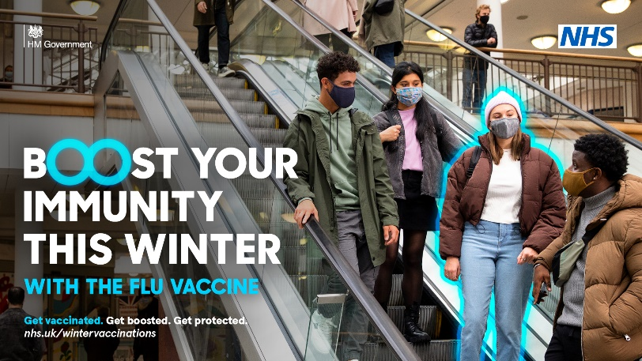
Flu – people with long term health conditions | Flu can both be life-threatening, and spread more easily in winter.  If you suffer with a long-term health condition you are more at risk and will need a flu jab.  Find out more: Flu vaccine - NHS (www.nhs.uk) | 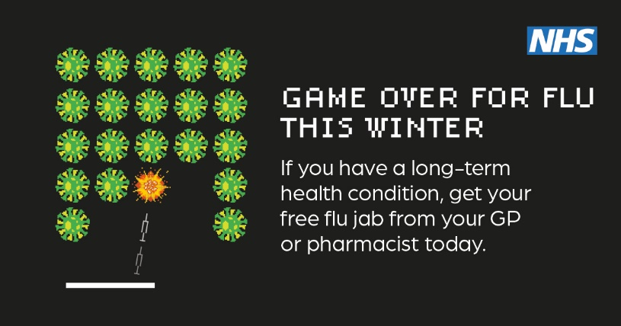
Flu – people with long term health conditions | The flu vaccine is offered free on the NHS to anyone with a serious long-term health condition, including:  - Asthma  - Diabetes  - COPD  - Heart conditions  And many more..  Find out more: Flu vaccine - NHS (www.nhs.uk) | 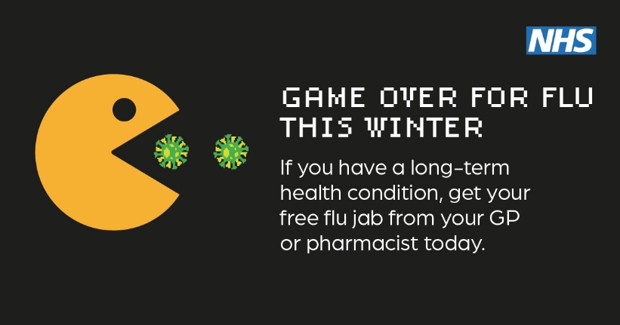
Flu – pregnant women | Keep you and your baby protected this winter by having a flu vaccine.  It's safe to have the flu vaccine at any stage of pregnancy.  Pregnant women can get their free flu vaccine through their GP, pharmacy, or midwife. | 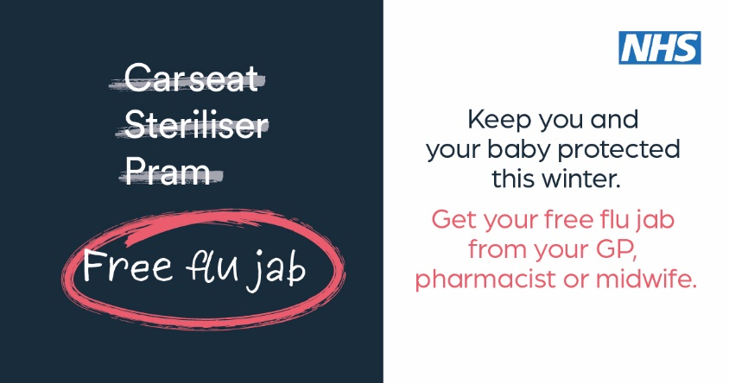
Flu – pregnant women | The flu vaccine is the best way to protect you and your baby against the flu virus.  It's safe to have the flu vaccine at any stage of pregnancy.  Don’t delay, book your appointment now. | 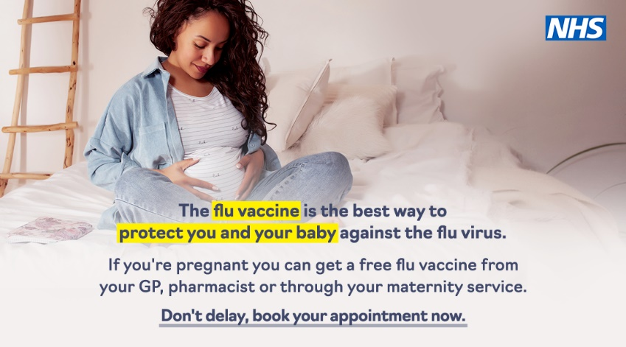
Flu – children | The children's nasal spray flu vaccine is offered every year to school children to help protect them against flu.  Flu can be a very unpleasant illness for children. It can also lead to serious problems, such as bronchitis and pneumonia.  Find out more: School Aged Immunisation Service Vaccines and immunisations (nottinghamshirehealthcare.nhs.uk) | 