NATH Clinical Supervision Resources
“De-briefing”

Definition
Debriefing is defined as a dialogue between two or more people; its goals are to discuss the actions and thought processes involved in a particular patient care situation, encourage reflection on those actions and thought processes, and incorporate improvement into future performance.
What skills will a Clinical supervisor need to undertake a de-brief
- Active listening
- Able to challenge and seek clarification.
- Able to pick up on verbal and non-verbal cues.
- Able to elicit ideas, thoughts, concerns, feelings.
- Able to negotiate an action plan with the learner on addressing learning needs
Organising a de-brief, what needs to be in place?
- Nominate a named clinical supervisor for the day.
- Protected time in the daily job plan for the supervising clinicians to undertake de-briefs.
- Decide whether to de-briefs after each patient or to at the end of the surgery. (Factors to take into account include the relative experience of the colleague being supervised and time!)
- Average amount of time for a de-brief can vary between 15-30 minutes after each session.
- With consent from the supervisee, debriefs can either be undertaken as a one-to-one or group based.
How to structure the de-brief discussion?
- Explore the following areas: data gathering (includes history/examination); making a diagnosis (appropriate and/or includes a range of differential); clinical management plan & prescribing (including F/U & safety netting); communication skills (enough information gathered to explore I.C.E); requesting appropriate investigations (appropriate and justified; working with colleagues (in-house or requiring advice/referral); and record keeping (succinct, relevant with appropriate red flags).
How to prioritise the cases for de- brief?
- You could discuss the cases, in order of being seen by the supervisee
- You could discuss cases, in which the learner has burning issues only.
- BUT discuss all cases until you, as clinical supervisor, are reassured from a patient safety and a clinical competency perspective.
Outcomes of de-briefing?
- PATIENT SAFETY FIRST!!!!
- Encourage the learner to Identify learning opportunities.
- Some brief teaching can occur but avoid a prolonged tutorial.
- Negotiate a plan with the learner, on how to address needs identified.
- Give feedback about performance or behaviour that leads to action to affirm or develop that performance or behaviour.
- Encourage reflective practice and lifelong learning.
- Focus on encouraging them to increase self-knowledge of their own strengths, weaknesses, and attitudes.

- Some useful tools to structure the de-brief
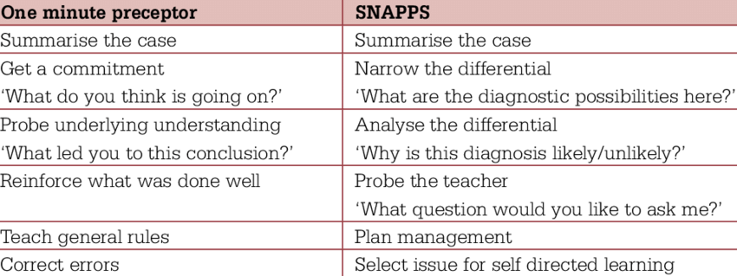

De-briefing: pitfalls to be aware of!
- Avoid the debrief becoming a Chat.
- Challenge appropriately but be specific with any feedback
- Reflect on what action would you take if the learner does not action what was agreed during the de-brief?
Benefits of de-briefing well?
- Reassurance to the supervisee
- Reassurance for the clinical supervisor on the performance of the supervisee
- Opportunity to affirm good practice
- Opportunity to provide constructive feedback and identify appropriate learning needs for the supervisee
- Opportunity to support the on-going professional development of the supervisee

