

**Workbook for Practice Assessor Preparation**

Contents

Introduction 2

MYNEE PLG 2

Learning Outcomes 2

Activity 1: Introduction 3

Activity 2: SSSA and the role of the practice assessor 3

Activity 3: Principles of assessment. 4

Activity 4: Giving Feedback 4

Activity 5: Using the MYEPAD as an assessor 7

Timeline of Assessment 7

The practice assessor, practice supervisor and academic assessor roles in the assessment process 9

Review a completed MYEPAD example 10

Activity 6: Assessment of proficiency 10

Activity 7: Struggling Students – the evidence base 11

Activity 8: Supporting Struggling Students 11

Activity 9: Case Studies – Struggling Students 12

Case Study 1: Meriel (Page 9-50) 12

Case Study 2: Josh (Page 51-54) 12

Case Study 3: Rachel (Page 55-59) 13

Activity 10: Support for Practice Assessors 14

Activity 11 (Optional) Supporting Learning Needs 14

Activity 12: Reviewing the Learning Outcomes 16

Completion 17

# Introduction

This resource has been launched in May 2021 to replace face to face teaching sessions in light of Coronavirus. It consists of this workbook, and a notepad which includes an example MYEPAD. **You will need both sections to complete preparation.** Try to work with them on screen, as the podcasts are not available if you print the workbook out and the notepad is a large document.

This preparation is aimed at staff who are already practice supervisors and now need to take on the role of practice assessor, in line with the NMC Standards for Student Supervision and Assessment (NMC 2018, (SSSA)). These new standards set out the NMC expectations for the support, supervision and assessment of students in placements. These standards replace the 2008 mentor standards and change the role of mentoring significantly.

The podcasts and activities in this workbook are designed for you to use at your own pace. That means the amount of time you take will be variable, but the maximum time expected for this workbook is 10 hours overall. You can do this in sections. There is a certificate to complete afterwards to send to your supervisor & assessor register holder. For NHS staff that will be their employer; for staff working in private, voluntary and independent organisations, that will be their local university or Training Hub. Details are at the end.

We hope you find this resource interesting and useful.

Any queries or feedback, please email [**Alliance.hub1@nhs.net**](mailto:Alliance.hub1@nhs.net)

# MYNEE PLG

The PAN Midlands, Yorkshire, North East and East Practice Learning Group (MYNEE PLG) started in 2016 with an original core aim to develop a common practice assessment document (PAD). Since inception it has grown to represent 33 universities across the Midlands, Yorkshire, East of England and more recently North East of England, hence the name change to MYNEE PLG. We collaborate to provide practice learning resources and support across all our member universities and work with other regional groups too. We have a website with more information at [www.myeplg.ac.uk](http://www.myeplg.ac.uk)

# Learning Outcomes

***By the end of this preparation participants will be able to:***

1. Enhance their understanding of the NMC Standards for Student Supervision and Assessment and the inter-relationship between the 3 roles of Practice Supervisor, Practice Assessor and Academic Assessor.
2. Recognise key elements of an effective practice based assessment process from the perspective of the practice assessor role
3. Demonstrate knowledge of the assessment process and assessment document, with specific reference to the practice assessors role, responsibility and accountability in protecting the public.
4. Identify local support mechanisms available to the practice assessor to enable them to develop emotional resilience and personal support strategies for this role.

# Activity 1: Introduction

You now have experience as a practice supervisor and as part of that role have completed formative assessment and feedback to your students contributing to the overall assessment decision made by the practice assessor.

Completion of this workbook will enable you to take on the role of practice assessor and contribute to the whole process of support, learning and assessment for students in your practice area. Before we start to look at assessment in more detail, take time to read the SSSA standards available at the link below, focusing specifically on the role of the practice assessor.

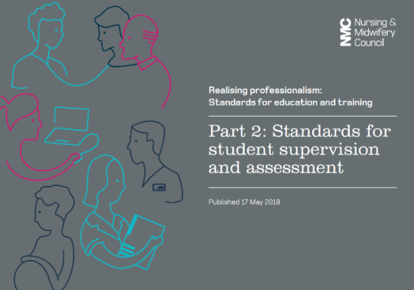 [NMC SSSA link](https://www.nmc.org.uk/standards-for-education-and-training/standards-for-student-supervision-and-assessment/)

Now take a few moments to consider the impact this will have on your role and how you will support other supervisors in your placement area and the student’s you will be assessing. You might want to make a few notes about your experiences as a supervisor and any concerns you may have about this or the assessor role. Is there anything also you want to find out as part of this preparation for the assessor role? Use the Notepad provided with this workbook to make notes.

When you are ready, move onto activity 2.

# Activity 2: SSSA and the role of the practice assessor

For activity 2 please listen to this short presentation on the assessor role and links to the NMC SSSA standards, then make some notes into your notepad.



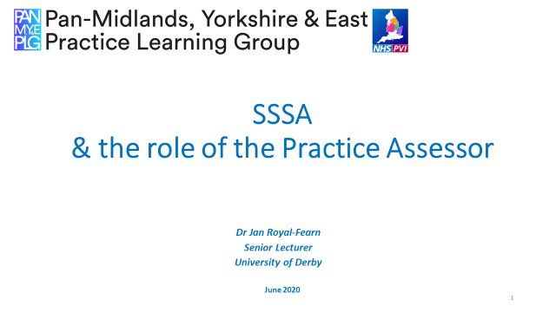

[Click here to listen](https://derby.cloud.panopto.eu/Panopto/Pages/Viewer.aspx?id=755db263-48be-4679-be7f-abe5010ea24a)

Then, when you are ready, move onto activity 3.

# Activity 3: Principles of assessment.

In order to fully understand your role as a practice assessor, you will first need to understand some elements of assessment theory. Please follow the [link here](https://drive.google.com/file/d/1M1ggKt2h5O-jnz3T_iGI9F_wsdvicx_G/view) then from the web page click the icon on the top navigation bar as shown, to download the 15 minute PowerPoint presentation



Once you have downloaded it, open the presentation and start the slideshow on ‘full screen’ view. This will start the audio commentary or you can start it by clicking on the loudspeaker symbol on the slide.

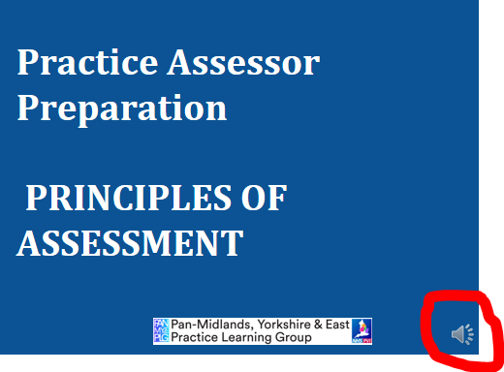

The audio will then begin to play, you may need to click the loudspeaker for each slide to play the audio depending on how you are viewing it.

Please work through the presentation and complete the activities as you do so. When you are ready move onto activity 4.

# Activity 4: Giving Feedback

Feedback can be done quickly without preparation, for example saying ‘“well done” to a learner when you have observed them complete a task in practice. At other times, it may be structured and planned, for example when it’s time to review their progress, or at the end of a placement. Feedback may be verbal or written but in the role as a practice assessor you are required to make an assessment decision on achievement and document your assessment.

Before we start learning more about feedback, take a few moments to consider how it feels to receive feedback. Using your Notepad, think about feedback you have received and consider:

* How did it make you feel?
* How was the feedback structured?
* What words were used to give praise or tell you improvement was needed?
* Did it have an effect on your learning?

A simple framework for giving feedback is known as a ‘feedback sandwich’. In this, you would start with a positive thing that the learner has done well, then move on to something they need to improve on and finally finish with another element that they did well. For example:

*“I noticed when you checked the consent record with Mrs Brown that you made eye contact and introduced yourself. However, you then did not check her identity according to policy by asking her date of birth. In the future, you will need to ensure to do this to ensure that you are speaking to the right patient. At the end of the conversation, though, you did make sure that she had no more questions before you left her, which was great.”*

Using this framework can be useful but does have limitations when using it with adults. They may only hear the negative element and so don’t take on board the things you have said that they did correctly. Overuse in practice can then make the feedback meaningless.

There are other frameworks and ways to give feedback. A useful one is that devised by Pendleton in 1984, which consists of:

| **Learner actions** | **Assessor actions** |
| --- | --- |
|  | 1. Checking that the learner is ready for feedback? |
| 1. What the learner thinks went well | 1. What the assessor thinks went well |
| 1. What the learner thinks could be done differently | 1. What the assessor thinks could be done differently |
| 1. What the learner thinks could be further improved | 1. What the assessor thinks could be further improved |
| 1. How this could be achieved |  |

Let’s watch a video that shows a doctor in the assessor role, giving feedback to a medical student using Pendleton’s framework. Don’t worry about the detail of the topic they discuss, but observe the feedback and how it is structured. See if you can identify Pendleton’s framework in the video and then consider if this may be a useful model for you to deliver feedback in the future to your learners. Make some notes in your Notepad on how feasible it is to use this structure in your role as an assessor.

 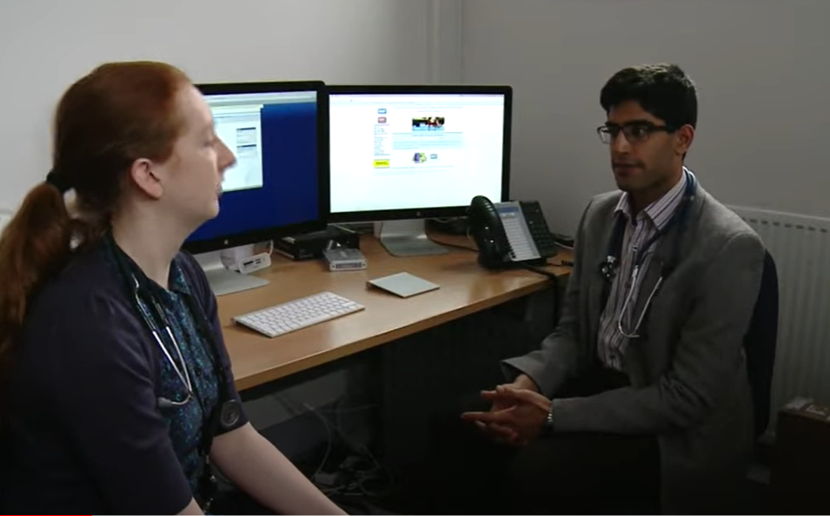

[Watch the video here](https://www.youtube.com/watch?v=HbFwBkCaMiM)

As a supervisor and an assessor, you will give the learner formative feedback as you observe them in practice – this should state what they do well and what could be improved. As a practice assessor you will also give summative feedback at the final interview. In all cases, feedback needs to be delivered in a timely manner, preferably in an uninterrupted space if that is possible in practice. Final feedback should be planned and will include documenting your assessment decision into the MYE PAD.

Feedback should be clear (and legible if it is handwritten). It should be focused and specific where possible. Generic feedback such as “worked well in practice and communicated nicely” does not help the learner or any future assessors.

Below are two examples from student practice assessment documents. Read them and look at the difference in the quality of the feedback for the student, for the university and for any future supervisor or assessor:

|  |  |
| --- | --- |
| **Feedback example 1**  “Nadima has done really well on this placement and has learned a lot. She is lovely and will make an excellent practitioner.” | **Feedback example 2**  “Nadima is an excellent student. She is very confident in what she does and is not afraid of asking questions or seeking help when needed. She has excellent communication skills, working in collaboration with the whole team. She effectively adapts to and manages challenging situations.  Nadima has been sensitive to patient needs and is aware of the importance of confidentiality. She has demonstrated excellent leadership skills during this placement.” |

|  |
| --- |
| **Finally, as you move into the role of practice assessor consider who you need to get feedback from?**  And how often would you expect to do this? Whilst busy days at work can make it difficult to get feedback from everyone you might plan to, you will need to feel sufficiently informed by others and have observed the student in practice to enable you to make your assessment decision. |

# Activity 5: Using the MYEPAD as an assessor

The aim of this activity is to understand the practice assessor role in conducting the assessment process and completing the practice assessment document. It should enhance your awareness of the key components of the MYEPAD and help you to develop a deeper understanding of the roles of the Practice Supervisor, Practice Assessor and Academic Assessor in completing the MYEPAD.

The following presentation introduces the MYEPAD using the Pebblepad software platform. This is the software used by students at the University of Derby, University of Nottingham, The University of Sheffield and Nottingham Trent University.

You may have already accessed this MYEPAD podcast as part of your practice supervisor preparation but you may want to revisit the podcast as a refresher. You can pause and rewind the podcast whilst you view. It is 17 minutes long. Click on the link below:

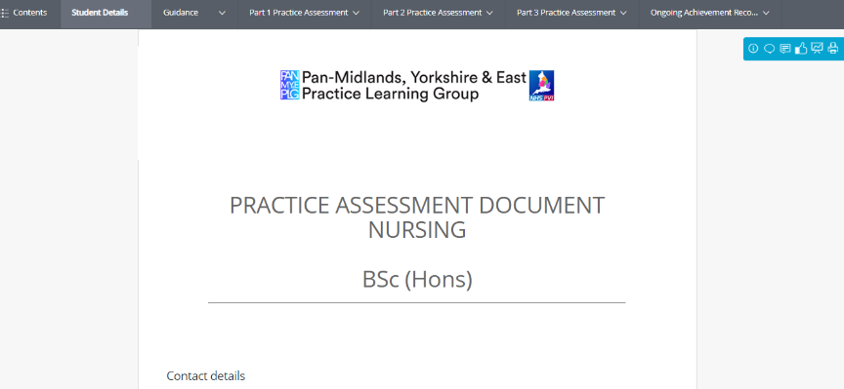

[MYE PAD Podcast](https://mediaspace.nottingham.ac.uk/media/MYEPAD+-+PP/1_88b04uac)

All sections of the MYE PAD are available at the PAN Midlands website as a downloadable version with a slightly different format. This would show you all the content across the whole programme if you would like to see that. It can be found at this link: [www.myeplg.ac.uk](http://www.myeplg.ac.uk)

## Timeline of Assessment

Consider the key components of assessment within the MYEPAD. Below are two timelines that give an overview of the order (timeline) in which the Practice Assessment should be structured during student’s typical placement. Imagine that these timelines represent a 1st year student on an eight week placement, review the timelines and decide which option you feel best identifies the sequence of the key components of assessment and best represent the assessment process. The top line represents the assessment process and the bottom line is the evidence which would be created to support the assessment process.

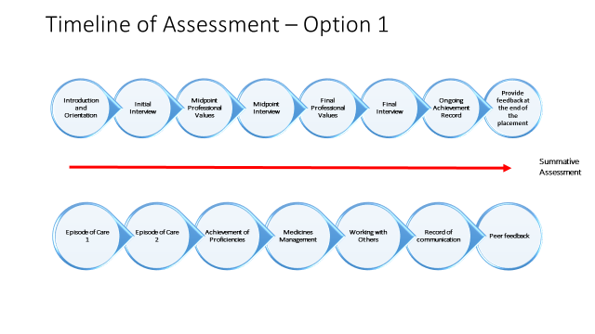

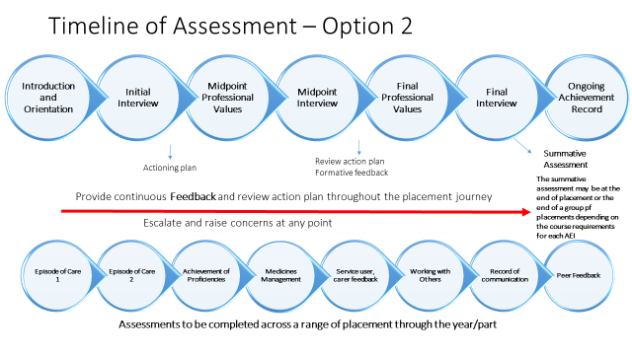

Use your notepad to document your answer and reflect on the decision that you have made.

The student’s placement should always commence with an introduction and orientation on the first day. The student should have an initial interview within the first week of placement and an action plan should be developed to focus the student’s learning and identify the practice assessments. The midpoint professional values and interview should be conducted halfway through the placement this provides a structure opportunity to give formative feedback on the students progression and action plan for the remainder of the placement. At the end of the placement the final interview should be conducted and the ongoing achievement record must be completed. The summative assessment point may be at the end of the placement or the end of a group of placements depending on the course requirements for each university.

Throughout the placement journey the student should receive regular feedback to ensure the student can develop and meet their assessments. Action planning and escalating concerns can also be completed at any point. This structure should be repeated for each placement.

During each placement the student should complete self-reflections on their progress and they should gather reflection/evidence of working with other inter-professionals. The Episode of Care 1 & 2, Medicines Management, Achievement of Proficiencies and Service User Carer Feedback should be completed across a range of placements throughout the year/part. Providing feedback, action planning and escalating concerns should also be completed at any point when required. There is opportunity to record any additional communications and in part 2 and 3 the students should collect peer feedback.

Option 2 (above) illustrates this comprehensive process and the key things to identify is the process of providing continues feedback, formative and summative assessment.

## The practice assessor, practice supervisor and academic assessor roles in the assessment process

Now consider the roles of the practice supervisor, practice assessor and the academic assessor and using your notepad write a list of who is responsible for completing the assessment.

Put the following key components of the practice assessment in to the appropriate boxes. Remember that you that the assessment may be undertaken or contributed to by more than one role.

Using your notepad reflect on;

* Please think about your role and how you work with the practice supervisor and academic assessor to conduct the student’s assessment.
* Do you understand the role of practice supervisor and how they can contribute to the assessment process?
* Do you understand the role of the academic assessor and how they can support the assessment process and also their role in confirming the assessment?
* For clarity on which roles complete each element of the assessment, spent a moment to review the following slide.

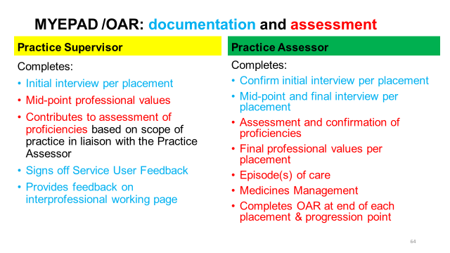

The Academic Assessor is responsible for the assessment elements above including medications management and episodes of care and then for confirming the assessment in the ongoing achievement record. Feedback and action planning should be conducted throughout the placement by the practice supervisors and assessor. Everyone has a responsibility to raise and escalate concerns.

## Review a completed MYEPAD example

As a practice supervisor you may feel you are familiar by now with aspects of the practice assessment document – MYE PAD. If you are not confident that you have this overview, then take a look at one for a student who is on placement with you. If you need more information you can read the detailed guidelines for completing the MYEPAD available [here](https://www.myeplg.ac.uk/documents/guide-to-using-the-myepad-validation-final-04-01-2019.pdf)

At this stage, these activities aim to enhance your understanding of the MYEPAD and provide you with an overview of the content and an example of the feedback, but we will build on this throughout the remainder of this workbook with a case study approach. When you feel ready, move onto activity 6.

# Activity 6: Assessment of proficiency

For this activity please choose just one NMC proficiency from the NMC standards your students need to achieve.

**NMC Standards for pre-registration nurses** (if you host nursing students)

<https://www.nmc.org.uk/standards/standards-for-nurses/standards-of-proficiency-for-registered-nurses/>

For nursing they are also in the students practice assessment document so you could look there if you have access to one. The MYE PAD for nursing is online at <https://www.myeplg.ac.uk/pan-midlands-practice-document.aspx>

**NMC Standards for Nurse Associates** (if you host trainee nurse associates)

<https://www.nmc.org.uk/standards/standards-for-nursing-associates/>

Using the document, select **just one proficiency** and consider how you would plan to assess a student’s achievement of that proficiency. Then go to your notepad and work through the sections under activity 6: Assessment of proficiency.

When you are ready, go onto the next activity.

# Activity 7: Struggling Students – the evidence base

For activity 7 please listen to this 24 minute presentation on the evidence base around assessing students who are struggling, then complete the activities in your notepad.





[**Click here to listen**](https://derby.cloud.panopto.eu/Panopto/Pages/Viewer.aspx?id=d0aded86-33ba-49b4-9700-abe501172bd3)

# Activity 8: Supporting Struggling Students

Activity 8 is another podcast focusing on the practical elements of managing failing students. This is 25 minutes long and there are no follow up activities for your notepad.

 

[**Click here to listen**](https://derby.cloud.panopto.eu/Panopto/Pages/Viewer.aspx?id=8bed89f6-b5b4-4182-afba-ac0200ee8e29)

This podcast gives examples and guidance on what to do as a practice assessor when the student is struggling. As you listen consider how the information links to your area of work and what support would be available to you if you had a struggling student.

When you are ready move onto activity 9.

# Activity 9: Case Studies – Struggling Students

Please use the MYEPAD Case Study example in your notepad for this activity to work through the case studies (Pages 8-59 of the notepad). Complete the activities and use your notepad to make additional notes and document your reflections.

## Case Study 1: Meriel (Page 9-50)

Meriel is a first year nursing student on her final placement for that year. She has completed an 8 week placement on a surgical ward and she is currently undertaking a final 6 week placement in your placement area and you have been allocated as her practice assessor. Meriel is now mid-way through the placement and you are required to undertake her assessment and complete the MYEPAD.

Using the copy of Meriel’s MYEPAD provided for this, you should review Meriel’s self-reflections and the feedback in the MYEPAD from the practice supervisors and consider her progress so far as part of the midpoint review. Complete the midpoint professional values (MYEPAD page 26) and the midpoint interview (MYEPAD pages 28-29) and provide feedback on Meriel’s progress and develop an action plan for the remainder of the placement.

**Things to consider:**

Review Meriel’s progress so far; review the episodes of care (MYEPAD page 42-47), proficiencies, working with others and feedback from the practice supervisors, student self-reflections and service user & carer feedback completed.

Look back at how Meriel was assessed in placement 1.

Complete the midpoint interview/action plan. Would you feel confident to sign off the midpoint professional values?

Consider what assessments still need to be achieved and think about the learning opportunities available on your placement area. Plan how Meriel can achieve this during the remainder of her placement.

Overall how is Meriel progressing? Is there anything outstanding that needs to be completed before the final interview?

## Case Study 2: Josh (Page 51-54)

Josh in the second year / part 2 of his course and he is on his second placement on an acute medical ward. You are Josh’s practice assessor but you have been feeling worried as you are now in week 6 of his 8 week placement and you have not spent much time together. Josh has had a lot of time off sick, and he has changed shifts without making you aware when you had planned his midpoint interview. This is yet to be completed. You were due to be working together today, but Josh has not arrived on duty as planned and has not rang the ward to make you aware.

You have concerns because when you reviewed his MYEPAD you noticed there is nothing written in the document and he has not documented any self-reflections or gathered any feedback over the past 6 weeks. You do notice that his Medicine management assessment has been completed, but you do not recognise the name of the person that has completed it and there is no feedback alongside this which make you concerned.

Two practice supervisors that have worked with Josh have raised some concerns regarding his professional behaviour. Josh was witnessed ignoring a buzzer when a patient required the toilet and Josh became confrontational when the staff nurse challenged his behaviour. The nurse in charge informs you that she has receive a patient complaint that Josh had spoken to a patient inappropriately and was asking the patient personal questions that made her feel uncomfortable.

At 10am Josh arrives on shift 3 hours late for a long day shift.

What action do you take?

Complete the professional values in the MYEPAD page 52-53

*(Only the professional values section of the MYEPAD has been provided in your notepad, please use the information provided in the case study above to make your assessment)*

What implications does this have for fitness for practice?

What would be your plan to complete the assessment for Josh?

## Case Study 3: Rachel (Page 55-59)

Rachel is a third year student and is in her fifth week of her placement on a surgical ward and you have been allocated as her practice assessor. Today you are meeting with Rachel for her midpoint interview andassessment of professional values.

Review Rachel’s MYEPAD (Page 55-59), consider the feedback in the Mid-point interview, the level of assessment required for PART 3 and the assessments that need to be achieved by the end of the year ready for registration. In the MYEPAD (Page 59) use the action plan template to develop an action plan to address the areas for further development, as identified in the midpoint interview documentation.

**Final Interview**

Your action plans were put into place and although Rachel has improved, her ability and confidence to perform is still poor and her knowledge is still limited when you ask her questions. Rachel is well liked by staff and desperate to qualify, as she is a single parent, with two young children.

In your MYEPAD (page 59) complete the action plan review/comments.

**Consider:**

Has Rachel met the objectives of the action plan?

What would you document at the final interview?

What are the implication if you sign her off?

What are the implications if you don’t sign her off?

At the end of these case studies use the space for any added notes / reflections you may have

# Activity 10: Support for Practice Assessors

By completing the activities and case studies above you will now realise that the practice assessor role has responsibility and accountability attached to it. However we must emphasise that this is not a role you should take on without support and indeed the NMC state in the SSSA standards (2018, section 8.2) that practice assessors should “receive ongoing support and training to reflect and develop in their role”

For this reason you will be able to access support when you require it from the academic assessor assigned to your student, and also from staff within your organisation who support supervisors and assessors. This will be different across many NHS trusts and private providers, so if you are unsure who you need to contact please seek support from your colleagues or from the academic assessor who will be able to advise you further in the first instance. No practice assessor should ever face the decision to fail a student, without letting the student know there are issues prior to the final interview and without discussing this first with the academic assessor. You will need to know where you can seek support in that situation.

The next activity (11) is optional. If you have completed this before in other preparation, you may choose to move directly to activity 12.

# Activity 11 (Optional) Supporting Learning Needs

Some of you completing this preparation to be a practice assessor may want to recap your knowledge of supporting students who have learning needs. Students may declare these specific needs at their initial interview or during their placement. The following content is duplicated from that provided as part of practice supervisor preparation, to enable you to recap and deepen your knowledge of supporting a student with learning needs, thinking now about your focus in the role of an assessor. This links to the content in earlier activities on struggling students, but please be aware that not all students who declare learning needs will be struggling students.

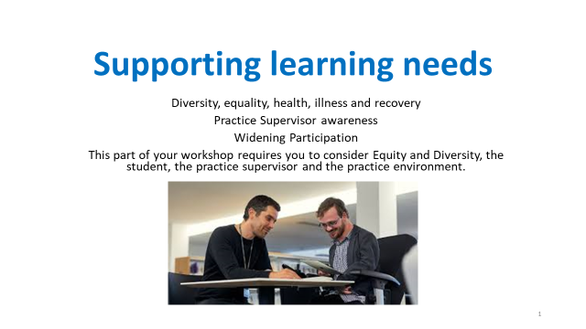

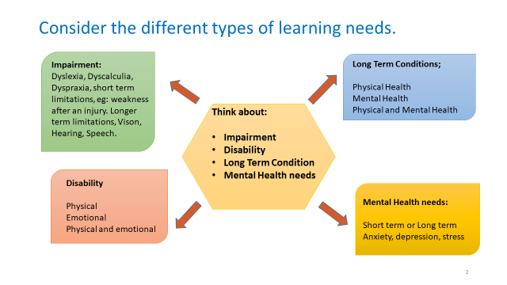

Take some time to read the RCN case studies, click on the links below.

[Case study 1](https://www.rcn.org.uk/get-help/member-support-services/peer-support-services/students)

[Case study 2](https://www.rcn.org.uk/magazines/students/2018/nurse-training-with-a-disability)

Then use your notepad to reflect on the statements there.

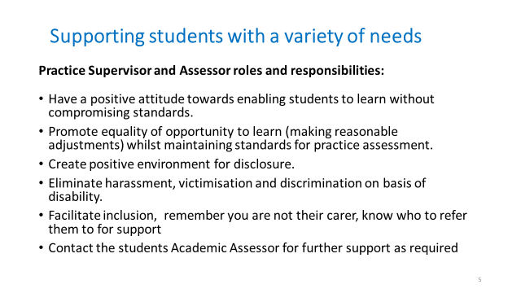

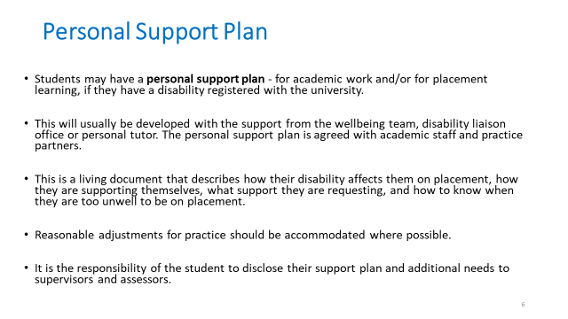

For further information and support;

* Contact the student’s Academic Assessor
* Contact the university disability support services.
* Access your local university website.

# Activity 12: Reviewing the Learning Outcomes

This is the end of the content for learning. At this point you may wish to reflect on the initial learning outcomes and consider how you think you have met them in completing the package. You could add some notes into your notepad on your achievement of these outcomes.

***By the end of this preparation participants will be able to:***

1. Enhance their understanding of the NMC Standards for Student Supervision and Assessment and the inter-relationship between the 3 roles of Practice Supervisor, Practice Assessor and Academic Assessor.

2. Recognise key elements of an effective practice based assessment process from the perspective of the practice assessor role

3. Demonstrate knowledge of the assessment process and assessment document, with specific reference to the practice assessors role, responsibility and accountability in protecting the public.

4. Identify local support mechanisms available to the practice assessor to enable them to develop emotional resilience and personal support strategies for this role.

# Completion

We hope you have enjoyed this learning package. After completing this learning

* Save the Notepad pages with your notes as evidence of your own continuing professional development and achievement of the learning outcomes. Don’t forget to use this for your NMC revalidation too.
* Complete the certificate at the end of the notepad and **return the certificate only to your register holder**.

**Please send a copy of the certificate** to your employer or supervisor / assessor register holder as evidence you have completed this preparation for practice assessor. In turn they can add you to the local practice assessor register and send any further details to you specifically relevant to your organisation.

**For Private, Voluntary & Independent Organisations** partnering with Nottinghamshire Alliance Training Hub (NATH) for student placements: send a copy of your certificate only to [**alliance.hub1@nhs.net**](mailto:alliance.hub1@nhs.net)

NATH hold the register of supervisors and assessors for Private, Voluntary & Independent Organisations.

**Thank you for the support you give our students**